Public Community Profile
Review

Mobile UI
No. | Screenshot | Review
1. |  | - Aktifkan tombol back (flowchart sudah diperbaiki)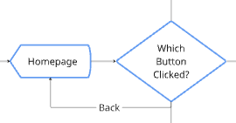  - < using community theme color (EPIC 02.01 Admin Community Profile, Community Color Theme Interaction: Change the color on elements like field outer, button and link.) Jadi semua yg link, gunakan warna tema komunitas.  - Community abbreviation using the colour < using now
2.

PC UI
No. | Screenshot | Review
1. |  | - Breadcrumdnya: Komunitas > [community abbreviation]    - Clicking Komunitas redirects to community list  - Komunitas using community theme color  - Community abbreviation using the colour Komunitas using now
2. | 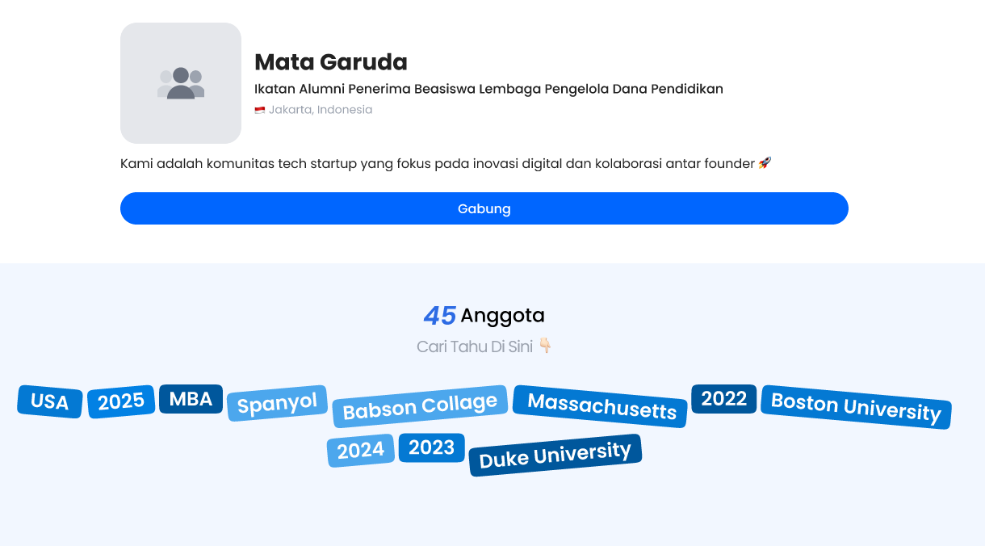 | - Frame profile width: 700 px  - Referensi:  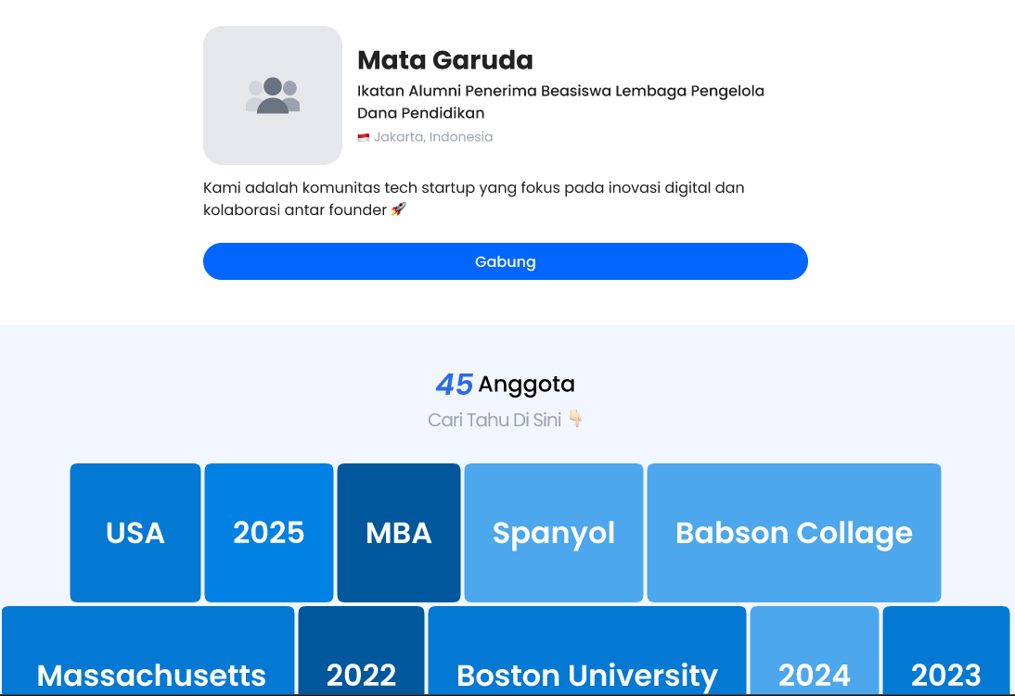
3

